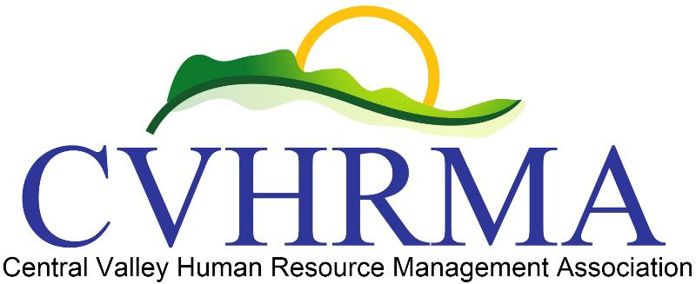Board Meeting Minutes for CVHRMA

Call to Order
A board meeting of CVHRMA was held on January 9, 2019 at City of Modesto downtown building. The meeting was called to order at 5:15pm and was presided over by Jowanda Collins, with Adrian Madrid as communication recorder.

Attendees –
Voting Members in attendance include Jowanda Collins, Christina Alger, Adrian Madrid, Louis Maldonado, and Jessica Laivo.
Members not in attendance include Sharon Pohl, James Anderson, and Sara Cordova.
No guests in attendance.

Approval of Minutes
The board reviewed minutes from the previous November 14, 2018 meeting and from the meetings held electronically on December 15, 2018 and December 20, 2018. Christina motioned to pass the minutes, Louis seconded. All other attendees voted in favor of approving the minutes.

Officers’ Items
- Jowanda (President) –
  - Update on Grimbleby Coleman services - Final billing for reconciliation work estimated at $3,000 which would cover tax years 2013 – 2018. They are moving forward with filing taxes and helping CVHRMA become current and up to date with our tax filings. Grimbleby Coleman requested a limited power of attorney to speak on our behalf on matters related to our nonprofit status and taxes. Grimbleby Coleman needs this so they can speak on our behalf to multiple agencies such as the State of California, Attorney General’s office, and the IRS. There will be three authorized representatives whose names will be listed on the documents along with their personal ID numbers. The actions they can perform will be limited to matters on our nonprofit status and taxes. Jowanda motioned to complete the limited POA agreement and Declaration of Representation. Christina seconded. All other attendees voted in favor of Jowanda’s motion. Jowanda will send to Adrian for recordkeeping.
  - Financials update – We currently have $13594.40 total between our Wells Fargo checking account, Paypal, and Quickbooks. We also have checks on hand to deposit. Jowanda will work on producing a monthly and quarterly financial report to be viewed by board members.
  - Update on tax nonprofit status – As mentioned earlier, Grimbleby Coleman is finishing up the filings for our taxes and nonprofit status. After transmission it’ll take about 6 months for a response. The outlook and feedback received has been positive so far. The State of California had no record of us, but because of the type of nonprofit CVHRMA is, we don’t need to register with them.
  - Doubletree contract update – Doubletree informed Jowanda about the change from a 12 month contract to a 6 month contract. When Doubletree offered Jowanda a 6 month contract with a scheduled review in May for the months of June-December, she responded with our concerns on why we need a 12 month agreement. Doubletree agreed to a contract that would include June-December, but just this one time. The pricing stayed the same although we may have to explore for 2020 given the concerns we have with the 6 month contract will arise again next year for 2020.
  - Speakers and sponsors 2019 – San Joaquin Valley College is sponsoring February’s luncheon. We still need sponsors for April and beyond. Craig from Payroll People has expressed interest in being a sponsor for upcoming luncheons and the conference. Payroll People could sponsor for April. One point has been our largest sponsor, including in 2018 with 3 luncheons and being the Premier sponsor for our fall conference. There has been no response on sponsorships for 2019. Jowanda will follow up to inquire if they’re still interested.
  - Open positions/recruitment efforts – Open positions include Treasurer, Workforce Readiness, and SHRM Foundation. The board also discussed recruiting for social media committee under Communications (Adrian) and event committee under Membership (Sharon). The Treasurer position is the most crucial to fill at this time.
  - 2019 events 2019 events – Christina, Sharon, and Adrian are going to the CalSHRM VLS in San Diego. We will send James to the SHRM Legislative Conference in March. Jowanda and Adrian will attend the SHRM Annual Conference in June at Las Vegas. We have also budgeted for two members to attend the SHRM VLS in November at Washington DC. The board discussed Jessica and Adrian to attend. CalSHRM will have quarterly meetings in April at Sacramento, July at San Jose, and October in long beach. The chapter President or an appointed board member needs to attend these meetings.
  - 2018 P&L and financial reports - Jowanda and Adrian distributed the 2018 P&L to the other board members via email.

- Christina (President-Elect) –
  - Next study group – Christina would like to recognize those who participated in the study group and successfully passed their certification exams at the luncheons. We discussed having another study group this fall. It would start in August and last until mid-October. We will need to start advertising no later than 2 months before the planned start date or by June 1st.
  - Official votes - Christina will send the official votes from the 2018 Fall Conference to the other board members. This includes both votes from survey monkey and paper ballots that were distributed at the conference.
  - Volunteer Leader Summit – Christina made travel and hotel arrangements for herself and Adrian. Sharon decided she will be responsible making her own arrangements to attend the VLS and submitting her reimbursements.
  - PDC Renewal – SHRM PDC is renewed for 2019 which includes January’s luncheon. We need to put the badge on the website. We are still waiting for HRCI. They questioned January’s luncheon and asked Christina to resubmit the application. Application was resubmitted and is currently “in process”. HRCI renewals would be for Feb 1 – Jan 31 time period.

- Other items
  - Monthly reconciliation meetings (Christina & Adrian) – During the meeting it was discussed that the monthly reconciliation meetings will take place on the 4th Wednesday of the month. During a later discussion between Christina and Adrian, it was agreed that the 4th Tuesday of the month would be more manageable for our individual schedules.
  - Membership report training (Jowanda & Sharon) – Jowanda and Sharon need to set a date & time to go over the Membership reporting. Jowanda will follow up with Sharon on the date for training. The board also discussed how it would be beneficial for Jessica to be included in this training, as well.
  - SHRM and CalSHRM trainings and webinars – Jowanda wanted to remind everyone of the available webinars, columns, and other helpful resources on the Volunteer Leadership Resource Center (VLRC) and CalSHRM website. CalSHRM also has monthly Membership calls and quarterly calls for Student Relations that would be beneficial for board members to participate in.
  - Website trainings – Kathleen said she was available to help with website training. Board members that should participate include Christina, Jessica, and Jowanda. It was suggested that the meeting place be held in Turlock since the travel distance would be close to in the middle for Kathleen and the other board members.
  - Bylaws – Bylaws have been sent to SHRM for review. We are expecting SHRM will respond soon. During discussion of the bylaws, the board discussed membership classifications. There are three classifications that needs to be assigned to all members: student, associate, and professional.

Adjournment

Adjourned at 6:40pm

