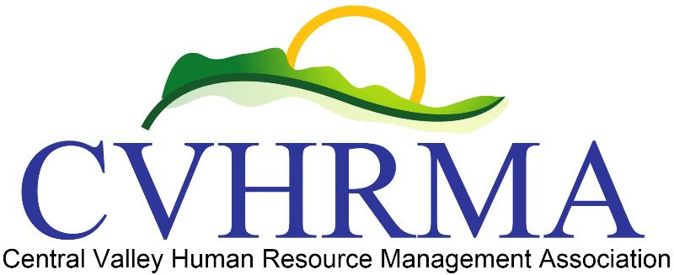Board Meeting Minutes for CVHRMA

Call to Order
A board meeting of CVHRMA was held via electronic communications beginning on February 13, 2019. The meeting was presided over by Jowanda Collins, with Adrian Madrid as communication recorder.

Attendees –
Voting members in the electronic communication included Jowanda Collins, Christina Alger, Adrian Madrid, Louis Maldonado, Jessica Laivo, Sharon Pohl, and James Anderson.

Officers’ Reports
- Jowanda (President) –
  - Jowanda and Adrian sent out a communication to the board to review an application from Cathy Adams applying for the position of Treasurer. Jowanda motioned to approve the Board appointing Cathy to the role as Treasurer. Christina seconded the motion. Jessica, Adrian, Sharon, and James voted in favor of.

Other Reports
None

Follow up items
Officer reports from February 13, 2019 board meeting
Board meeting March 13, 2019

