California State Council of SHRM
SHRM California Employment Law Micro-Credential
Westin San Diego Hotel, San Diego, California
2-Day Live In-Person Workshop
January 24 & 25, 2019

Build expertise and expand your influence by earning a SHRM Specialty Credential. These specialized credentials allow HR professionals to demonstrate targeted expertise in several key areas while enhancing credibility among peers and employers. Earning a SHRM Specialty Credential is an investment in your continued career development and can be accomplished by engaging in content-specific, competency-based education and achieving a successful score on an online assessment. Specialty Credentials are an approved professional development activity for recertification credits towards your SHRM-CP® or SHRM-SCP® certification.
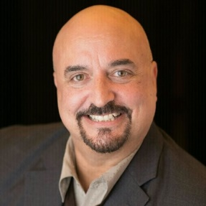

Your Workshop Instructor and California Employment Law Expert
Michael Letizia
SHRM-SCP, CELM
CalSHRM Past State Director
President Letizia HR Solutions, Inc.

SHRM California Employment Law Micro-Credential
Our workshop includes:
- 2 full days of classroom education by a SHRM California expert;
Covering 4 comprehensive SHRM eLearning courses:
  - California Wage and Hour Laws
  - California Leaves of Absence
  - California Privacy, Security, Health and Safety
  - California Benefits
- Access to the on-line California knowledge assessment, distributed by SHRM

Note: You do not have to be SHRM-certified to earn the SHRM California Employment Law Micro-Credential; however, you will receive 25 PDCs towards your SHRM-CP or SHRM-SCP recertification upon completion of the Micro-Credential package.
Now is the time to register as seating is limited for this special event!
SHRM Member: $1,495.00
Non-Member: $1,694.00

Use this link to register for the CalSHRM California Employment Law Micro-Credential:
http://www.cvent.com/m-events/Info/Summary?e=ea2f8392-8efc-49ac-8868-b1771db9c920

Use this link for lodging at Westin San Diego Hotel:
http://www.cvent.com/m-events/Info/CustomPage?cpid=17&e=ea2f8392-8efc-49ac-8868-b1771db9c920

