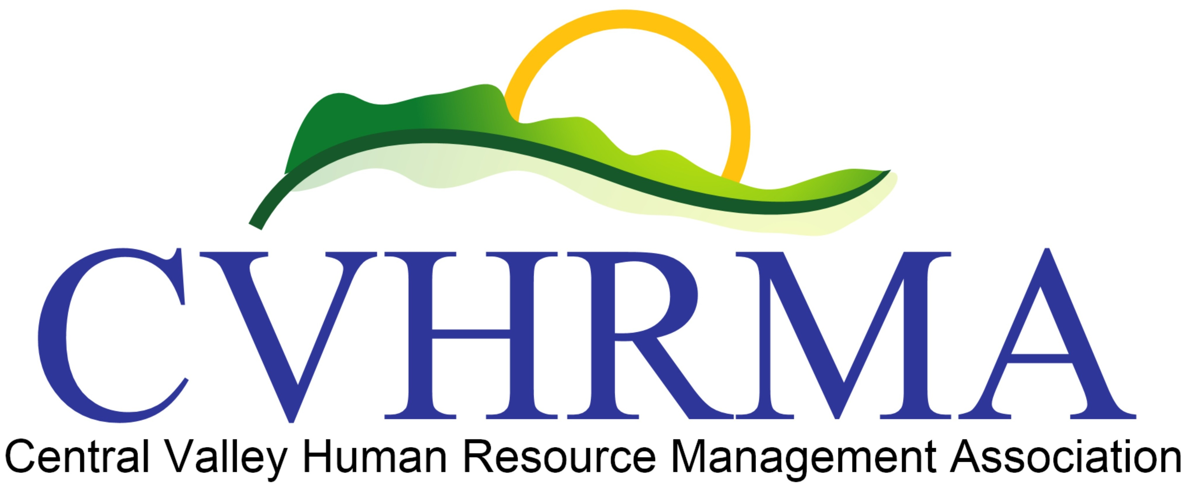
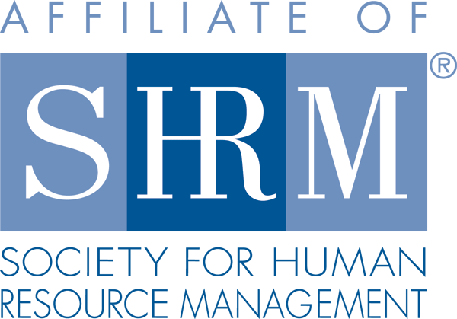

Central Valley Human Resources Management Association
Receives Prestigious SHRM Award for Advancing the HR Profession

ALEXANDRIA, Va., May 19, 2017 — The Society for Human Resource Management (SHRM) recently awarded the Central Valley Human Resource Management Association its prestigious EXCEL Platinum Award for the Chapter’s accomplishments in 2016.

The award aligns individual chapters and state councils’ activities with SHRM’s aspirations for the HR profession. The award recognizes accomplishments and strategic activities and initiatives that enhance the human resources profession.

“Advancing the human resources profession is a daily mission at SHRM and this Chapter’s outstanding work this year contributed significantly to that goal,” said Henry G. (Hank) Jackson, president and CEO of SHRM. “Recipients of this prestigious award are those who show a strong commitment to advancing the HR profession through service to the community, local networking, and professional development activities.”

The EXCEL award can be earned at four levels: bronze, silver, gold and platinum, and each level has a prescribed set of requirements and accomplishments that must be met. Central Valley Human Resource Management Association (CVHRMA) will receive recognition in SHRM publications and at conferences, a logo to display on their website and information to share with their members about the significance of this award.

Accomplishments included: an increase in local membership of 55%, awarding an HR Student of the Year from CSU Stanislaus with a scholarship and increasing donations from their local chapter to the SHRM Foundation by more than 300%!

For more information about the CVHRMA visit: www.cvhrma.org
The Mission of CVHRMA is to serve the needs of HR professionals by providing the most comprehensive professional development and resources available. As an influential voice, we strive to ensure that HR is recognized as an essential partner in developing and executing organizational strategy. Our monthly luncheons offer continuing education hours for HRCI and SHRM PDC’s for Certified HR Professionals.
Media: For more information, contact Dawn Tacker, President of CVHRMA at 209-505-4160 and president.cvhrma@gmail.com

About the Society for Human Resource Management

The Society for Human Resource Management (SHRM) is the world’s largest HR professional society, representing 285,000 members in more than 165 countries. For nearly seven decades, the Society has been the leading provider of resources serving the needs of HR professionals and advancing the practice of human resource management. SHRM has more than 575 affiliated chapters within the United States and subsidiary offices in China, India and United Arab Emirates. Visit us at shrm.org and follow us on Twitter and Instagram @SHRMPress.

